(3 points) One gm of radium (mass number 226) has an activity equal to 1 curie. What is the approximate half-life of Radium in years? (Avogadro number = 6 x 10^[23])

3/3

1600

160

1.6

0.0016

(3 points) Two protons (with rest mass m) moving towards each other with equal and opposite velocity (v), collide and produce two protons and another particle of rest mass M. What is energy of each proton (before the collision) if all the reactant particles are produced at rest in the C.O.M frame after the collision? (Assume c=1)

3/3

2m+M

m+M/2

M

m+2M+(M^2/2m)

(1 point) Two nuclei (A and B) mass numbers 2 and 128 respectively. The ratio of their radii (radius of nucleus A over nuclei B) is equal to

0/1

1:4

1:8

1:64

None of the above

Correct answer

1:4

(1 point) Two nuclei X and Y have mass numbers equal to 23 and 25 and atomic number equal to 12 and 14, respectively. These nuclei can be considered as

1/1

Isotopes

Isobars

Isotones

None of the above

(1 point) A particle of rest mass m has (relativistic) K.E. equal to 3mc^2. So total momentum of the particle is equal to?

1/1

sqrt(6) mc

2 mc

sqrt(15)mc

sqrt(3)mc

(1 point) A radioactive element has a half-life of 20 years. What fraction of nuclei (from this element) would have decayed after 40 years?

1/1

1/4

3/4

1/2

Cannot be determined

(3 points) An elementary particle has a rest lifetime of 10^{-5} secs. What is the total distance travelled (as seen by an observer at rest if was created with a speed of 0.99c (where c=3 x 10^8 m/sec)

3/3

21300 m

3000 m

30,000m

30 m

(1 point) Photons obey which of the following statistics/laws?

0/1

Maxwell Botzmann statistics

Fermi Dirac statistics

Bose Einstein statistics

Planck's law

Correct answer

Bose Einstein statistics

Planck's law

Question

0/3

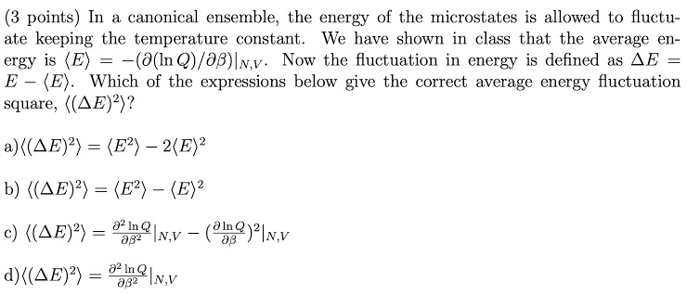

a)

b)

c)

d)

Correct answer

b)

d)

(3 points) In a laser cavity there are 10^10 stimulated emissions occurring per second per cm^3. Assume that in a steady state operation all of the energy of these stimulated emissions goes into laser light. The energy level separation of the lasing levels is 20eV and the length of the optical cavity is 20cm. What is the intensity of the laser beam?

3/3

0.64 microWatts/cm^2

0.23 microWatts/cm^2

1.5 microWatts/cm^2

92 nanoWatts/cm^2

Question

3/3

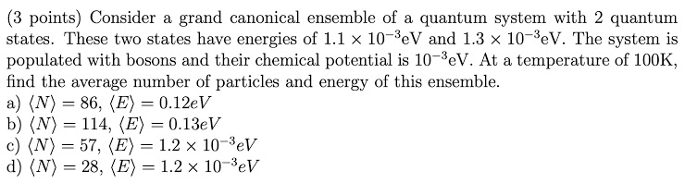

a)

b)

c)

d)

Question

1/1

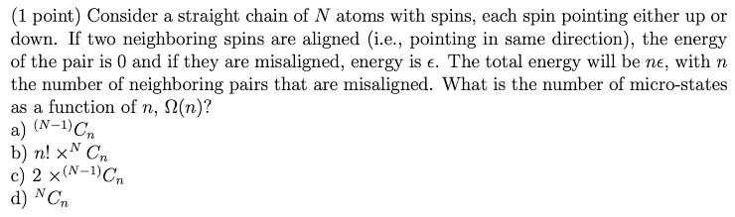

a)

b)

c)

d)

Question

1/1

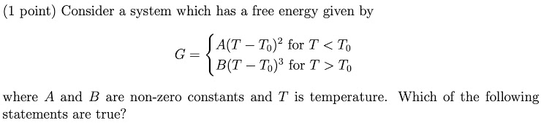

There is a zeroth order phase transition at T=T0

There is a first order phase transition at T=T0

There is a second order phase transition at T=T0

There is no phase transition

(1 point) As a ferromagnetic substance is heated, which of the following happens?

1/1

It transitions to a paramagnetic substance

It transitions to a diamagnetic substance

Its entropy changes discontinuously at the Curie temperature

Its entropy changes continuously at the Curie temperature

(1 point) What is the average kinetic energy of an ideal gas atom at 300K?

1/1

0.039eV

0.013eV

0.026eV

7.3X10^(-20)J

(1 point) In a Stern-Gerlach experiment with a spin 3/2 particle the following will be observed

1/1

Four states

+3/2, +1/2, 0, -1/2, -3/2

No z-component of spin is zero

Five states

(1 point) The 1-D potential is V(x)= x^2 cos(x), what is the expectation value of x?

1/1

1

x

x^2

0

(1 point) A quantum particle with energy E at high temperature will follow which distribution?

0/1

FD

BE

FD and BE

MB

Correct answer

MB

(1 point) Consider a 2-D infinite well potential. What is the degeneracy of the first excited state?

1/1

1

2

3

0

(3 points) Consider the electron density at T=0 as n, and Fermi energy =Ef. The follow relations are true.

0/3

Ef=n^{2/3}

Electron distribution function=1 for E < Ef

Electron distribution function =1 for E > Ef

nf= Ef

Correct answer

Ef=n^{2/3}

Electron distribution function=1 for E < Ef

(3 points) Consider a particle in a 1-D infinite potential well between x=0, L. Calculate the probability of the particle to be within x=0, L/a and the followings are true. Usual notations are used.

3/3

1/a + Sin(2\*n\*pi\*/a)/(2\*n\*pi)

1/a

1/a - Sin(2\*n\*pi\*/a)/(2\*n\*pi)

1/a for large n

(3 points) Consider 1 g of marble inside 1 cm long tube. Consider this is as a 1-D infinite potential well and calculate the quantum number n for the energy E=1 mJ and the exception energy to promote it to the next level. The symbols are usual.

3/3

4.27 \*10^{28}, 4.69\*10^{-32} J

4.27 \*10^{-28}, 1m J

4.27 \*10^{20}, 4.69\*10^{-32} J

1000.0, 4.69\*10^{-32} J